

***Dissertation on***

**“****Smart Classroom** **Environment”**

*Submitted in partial fulfilment of the requirements for the award of degree of*

## Bachelor of Technology in

**Computer Science & Engineering UE18CS390A – Capstone Project Phase - 1**

***Submitted by:***

|  |  |
| --- | --- |
| **Naik Bhavan Chandrashekhar Akshaya Visvanathan Atharva Moghe**  **Akhil S Kumar** | **PES2201800047 PES2201800089 PES2201800131**  **PES2201800137** |

*Under the guidance of*

**Dr. Annapurna D.** Professor, CSE   
PES University

### January - May 2021

**DEPARTMENT OF COMPUTER SCIENCE AND ENGINEERING**

FACULTY OF ENGINEERING

### PES UNIVERSITY

(Established under Karnataka Act No. 16 of 2013) Electronic City, Hosur Road, Bengaluru – 560 100, Karnataka, India



## PES UNIVERSITY

(Established under Karnataka Act No. 16 of 2013)

Electronic City, Hosur Road, Bengaluru – 560 100, Karnataka, India

### FACULTY OF ENGINEERING

CERTIFICATE

*This is to certify that the dissertation entitled*

**‘Smart Classroom Environment’**

*is a bonafide work carried out by*

|  |  |
| --- | --- |
| **Naik Bhavan Chandrashekhar Akshaya Visvanathan Atharva Moghe**  **Akhil S Kumar** | **PES2201800047 PES2201800089 PES2201800131**  **PES2201800137** |

In partial fulfilment for the completion of sixth semester Capstone Project Phase - 1 (UE18CS390A) in the Program of Study -Bachelor of Technology in Computer Science and Engineering under rules and regulations of PES University, Bengaluru during the period Jan. 2021 – May. 2021. It is certified that all corrections / suggestions indicated for internal assessment have been incorporated in the report. The dissertation has been approved as it satisfies the 6th semester academic requirements in respect of project work.

|  |  |  |
| --- | --- | --- |
| Signature  **Dr. Annapurna D.**  Professor, CSE | Signature Dr. Sandesh B J  Chairperson | Signature  Dr. B K Keshavan Dean of Faculty |

**External Viva**

|  |  |
| --- | --- |
| **Name of the Examiners**  **1.**  **2.** | **Signature with Date** |

## DECLARATION

We hereby declare that the Capstone Project Phase - 1 entitled **“Smart Classroom Environment”** has been carried out by us under the guidance of Dr. Annapurna D., Professor, CSE and submitted in partial fulfilment of the course requirements for the award of degree of **Bachelor of Technology** in **Computer Science and Engineering** of **PES University, Bengaluru** during the academic semester January – May 2021. The matter embodied in this report has not been submitted to any other university or institution for the award of any degree.

|  |  |  |
| --- | --- | --- |
| **PES2201800047**  **PES2201800089**  **PES2201800131**  **PES2201800137** | **Naik Bhavan Chandrashekhar**  **Akshaya Visvanathan**  **Atharva Moghe**  **Akhil S Kumar** |  |

## ACKNOWLEDGEMENT

I would like to express my gratitude to Dr. Annapurna D., Department of Computer Science and Engineering, PES University, for her continuous guidance, assistance, and encouragement throughout the development of this UE18CS390A - Capstone Project Phase – 1.

I am grateful to the Capstone Project Coordinator, Dr.Sarasvathi V, Associate Professor, for organizing, managing, and helping with the entire process.

I take this opportunity to thank Dr. Sandesh B J, Chairperson, Professor, Department of Computer Science and Engineering, PES University, for all the knowledge and support I have received from the department. I would like to thank Dr. B.K. Keshavan, Dean of Faculty, PES University for his help.

I am deeply grateful to Dr. M. R. Doreswamy, Chancellor, PES University, Prof. Jawahar Doreswamy, Pro Chancellor – PES University, Dr. Suryaprasad J, Vice-Chancellor, PES University for providing to me various opportunities and enlightenment every step of the way. Finally, this Capstone Project could not have been completed without the continual support and encouragement I have received from my family and friends.

## ABSTRACT

For years, universities have been using traditional methods as they bring about a sense of familiarity and comfort. However, the key to increase the productivity and enhance the learning experience lies in the modernization of our college campuses.

Our work focuses on two of the most pressing issues - attendance and unsolicited energy consumption. Our goal was to overhaul the manual system, without compromising its integrity. A portable RFID fingerprint scanner that must be activated by the professor, thereby making our system failproof.

The data generated is stored in a cloud server and is used to draw behavioural patterns. We are accustomed to leaving our fans and lights unattended, which poses a serious environmental threat.

Our solution is to a build a smart eco-system to detect the presence of a person, and automatically switching on the necessary appliances. This in combination with machine learning algorithms can adjust the speed of fans and brightness of lights based on external factors.

**TABLE OF CONTENTS**

|  |  |  |  |
| --- | --- | --- | --- |
| **Chapter No.** | **Title** | **Page No.** |  |
| **1.** | **INTRODUCTION** | **8** |  |
| **2.** | **PROBLEM DEFINITION** | **10** |  |
| **3.** | **LITERATURE SURVEY**   * 1. Smart university, a new concept in the Internet of Things.   2. Smart attendance system based on frequency distribution algorithm with passive RFID tags.   3. Automatic lighting and Control System for Classroom.   4. Smart Attendance Monitoring System (SAMS): A Face Recognition based Attendance System for Classroom Environment | **13**  **13**  **16**  **19**  **22** |  |
| **4.** | **DATA**   * 1. Overview   2. Dataset | **24** |  |
| **5.** | **SYSTEM REQUIREMENTS SPECIFICATION** | **27** |  |
| **6.** | **SYSTEM DESIGN** | **34** |  |
| **7.** | **CONCLUSION OF CAPSTONE PROJECT PHASE - 1** | **48** |  |
| **8.** | **PLAN OF WORK FOR CAPSTONE PROJECT PHASE - 2** | **49** |  |
| **REFERENCES/BIBLIOGRAPHY** | | **49** |  |
| **APPENDIX A DEFINITIONS, ACRONYMS AND ABBREVIATIONS** | | **51** |  |
| **APPENDIX B USER MANUAL** | | **52** |  |

## LIST OF TABLES

|  |  |  |
| --- | --- | --- |
| **Table No.** | **Title** | **Page No.** |
| 1 | Software Requirements | 35, 43 |
|  |  |  |

**LIST OF FIGURES**

|  |  |  |
| --- | --- | --- |
| **Figure No.** | **Title** | **Page No.** |
| 1  2  3  4  5 | Use Case Diagram for Smart University  System Workflow for Attendance System  Flowchart for Lighting and Control System  Block Diagram for Smart Attendance System  Block Diagram for Electricity Optimization | 14  17  21  34  35 |
| 6  7  8  9  10  11  12 | Master Class Diagram  State Diagram for Smart Attendance  State Diagram for Electricity Optimization  User Interface Diagram  Packaging Diagram  Deployment Diagram for Smart Attendance System  Deployment Diagram for Electricity Optimization | 40  41  42  42  44  45  45 |

# CHAPTER-1

**INTRODUCTION**

“The Internet of Things is a novel cutting-edge technology that offers to connect a plethora of digital devices endowed with several sensing, actuation, and computing capabilities with the Internet, thus offering manifold new services in the context of an intelligent environment.” These improvements and methods are credited with improving the quality of human life across various sectors, including healthcare, education, administration, city planning, energy consumption, etc.

“Gartner, Inc. forecasts that the enterprise and automotive Internet of Things (IoT) market will grow to 5.8 billion endpoints in 2020, a 21% increase from 2019.” Retrospectively, that adds up to a large number of interconnected devices. Studies and estimates project that by 2030, the worldwide count of IoT devices may be as large 125 billion.

“The Internet of Things (IoT) is a revolutionary communication paradigm that aims to bring forth an invisible and innovative framework to connect a plethora of digital devices with the Internet.” The primary focus of IoT as a concept is to make the internet universal and remotely accessible to all. After many years of its existence, IoT is continuing to gain momentum as the opportunities it offers are endless.

An IoT-based smart eco-system can be broadly defined as a large number of interconnected devices. Each of these devices have the capability to generate a vital piece of information and possesses the sensibility and infrastructure to share it with the other devices in the network. “IoT devices can use any available communication networks such as public Wi-Fi, Bluetooth, cellular networks (LTE/LTE-Advanced), and satellites to communicate with the cloud-based application center.” Some of the challenges faced in terms of the connectivity of the IoT devices are as follows:

• It is challenging to provide a strong and stable connection to mobile devices such as vehicles.

• Transition from low level to high level connectivity

• Communication devices must be present in addition to the large number of IoT devices, especially if they are spread over a large area.

The first step in creating innovative solutions to a problem is to identify and thus understand the problem itself and the scope of impact it has. This can be followed by an idea on how the Internet of Things can play a role in tackling such a scenario. High investment costs and security deter university managements from implementing a fully IoT-based eco-system. Our project hopes to take the first step in this direction.

Keeping the above scenario in sight, our goal is to identify and solve the most common problems faced in any educational institution, taking our own university as a canvas.

For a long time, attendance has always been taken manually. This has caused multiple discrepancies and has wasted useful class time. In addition to this, classroom equipment like fans etc. have occasionally been left on thereby wasting considerable energy.

Our approach is a fully edge computed, integrated biometric-based solution for attendance which is modular and carried by the teacher to ensure security. An ambient and spatial sensor-based approach to dynamically turn on and off the fans and lights based on the occupants of the room.

# CHAPTER-2

# PROBLEM DEFINITION

# 2.1 Problem Statement:

# A proposal for an IoT-based intelligent environment, with the primary objective of energy optimization and an intelligent, yet reliable attendance system that focuses on reducing latency to give an enhanced learning experience.

# Any educational organization (it maybe small or large) requires a students or employees attendance tracking system for the effective maintenance of different projects and tasks assigned to them. The management finds it absolutely necessary to collect and maintain up to date attendance data, sometimes even over a span of several months. This not only shows professionalism but also is crucial in case of any discrepancies in the future. We have seen that manual attendance tracking is a very tedious and inefficient process for even a fairly large group of students. Hence, an automated system of attendance takes a huge leap in this scenario.

# A smart attendance system is very essential in present days. An effective and adequate system of attendance helps in monitoring the punctuality and progress of students and also, managing the absence of people. There are a few steps to enabling a smart attendance system. It consists of setting up the workflows for attendance and also maintaining a proper validation of student’s effective class time. However, this should be implemented by keeping the sensitive nature of data in mind. The chances of bypassing such a system must be minimized.

# Another major issue observed in a university campus is the unrestrained use of electricity. This puts a direct strain on our country’s energy resources and in turn cause irreparable damage to the environment. As a responsible human, it is our duty to conserve the earth and leave behind a better world for our future generations. Unattended fans, lights and other electrical appliances account for a large portion of our country’s economy.

# 2.2 Current System

# Attendance is a crucial factor that plays a key role in understanding the student’s psyche in their formative years in school and college. In most cases, the attendance of a student is a direct indicator of his or her personality and helps keep track of their extra-curricular activities. Studies and research show that regular attendance of the students show their interest towards the particular subject and also effectively reduces the chances of them being involved in other destructive activity. Unattended absence can be one of the major reasons for students to dropout without receiving complete education and thus lowers our country’s literacy rate.

# The common drawbacks that the traditional attendance systems are prone to are:

# • Wastage of lecture hours by calling out student names

# • Higher changes of impersonation, miscommunication, human errors, etc., all of which affect the integrity of the data

# The existing solutions to tackle the above problems include automatic face detection and RFID scanners.

# “Developed in 2001 by Paul Viola and Michael Jones, the Viola-Jones algorithm is an object-recognition framework that allows the detection of image features in real-time. Viola-Jones outlines a box and searches for a face within the box.” This method, however, is prone to errors and failure to recognize a valid person’s face is a common occurance. It also poses a lag of a few seconds as the system needs to detect a face. The algorithm used also gives best results in the frontal view of the face and might fail in other cases.

# Radio-Frequency IDentification (RFID), because of its “strong anti-interference capability and non-intrusiveness”, is an effective tool to tackle the above problem. However, this too can be easily by passed as the RFID tags are easy to transport and hence reliability becomes a matter of concern.

# Electricity consumption is one of the biggest concerns affecting the world community. It is a

# common observation in most colleges and universities that most students and teachers are habituated to leaving the lights, fans and other electrical appliances in their classrooms, labs and lecture halls perpetually switched on, irrespective of their need. This has an adverse effect on the overall energy consumption of the country and results in unnecessarily higher electricity bill, causing a leak in the management’s budget.

# “The system developed will control lighting in particular area of classroom based on the presence of human using relay control compared to the one placed in ceiling which would switch on or off based on presence of human in room irrespective of position.” Many existing system use motion sensors and an Arduino UNO to implement as automatic system of lights and fans. However, due to the low computational power of an UNO, the cost incurred as a result of the number of microcontrollers required is high.

# Our primary objective is to overhaul the existing traditional system of attendance system to make it more seamless, effortless and less time consuming. Our system also is equipped to ensure that the lights and fans turn off automatically when not needed thereby significantly decreasing the energy footprint of the classroom. Our final deliverable would also include a cloud-based dashboard containing analysis on the number of students attending classes and the overall intake and timing on a per subject basis. This would be managed by a system administration.

# Our end system will also be equipped with the ability to perform analysis on the data collected and stored in our cloud server in order to draw conclusions and take future decisions based on Machine Learning algorithms. This is especially significant in adjusting the speed of the fan based on the external conditions such as temperature, humidity, etc.

# CHAPTER-3

**LITERATURE SURVEY**

**3.1 Smart University, A New Concept in IoT**

**3.1.1 Introduction**

The concept of smart environment in this given paper is defined like a small world where devices enabled by sensors and networking work together continuously to make the lives of those in the environment more comfortable.

Our university campuses boast a wide range of mobile as well as stationary devices that are connected to the Internet. This multitude of devices results in an enormous inter-connected network of smart objects, essentially giving birth to an Internet of Things, in its truest form. The interesting part in this scenario is that college campuses have varied types of such devices. The simplest ones being doors, windows, fans, printers, projectors, books, benches, etc. to the buildings, classrooms, canteens, etc. All these devices can be made intelligent by attaching sensors, QR tags, RFID, NFCs, thus bestowing upon them the ability to not only collect but also analyze a large volume of data and make decisions. These smart objects can collaborate to transform a traditional university, into a Smart University.

**3.1.2 Concept**

***The many sensors that can be attached to the various static and dynamic devices around the campus premises may give rise to the following mini smart eco-systems within the university:***

* Smart Parking: Monitor the parking system of the university and keep a note of the number of vacant spots in the lot to avoid jams at the entrance of the parking lot.
* Smart Lighting: Adjust the lights in the classroom automatically based on data received from sensors about the power of natural light, which in-turn will eventually help us reduce electricity consumption.
* Smart Tracking: Use of RFID technology to realize monitoring students inside the campus and their quick evacuation in emergencies; both goods and equipment can be monitored.
* Smart Inventory: Every component used (like CPU, printer, monitor, mouse, scanner, copier, etc.) will have a bar code associated with it which represents the inventory number and the QR tag. We can identify the component and display all of its information like technical specifications, administrator, etc. by connecting a device to the Internet with a barcode reader.
* Smart Food Redistribution System: One of the more humanitarian aspects and an absolute necessity in today’s world, the excess food from the college canteen can be transported to the nearest orphanage or hospitals. This would effectively reduce food wastage and also help those to need it.

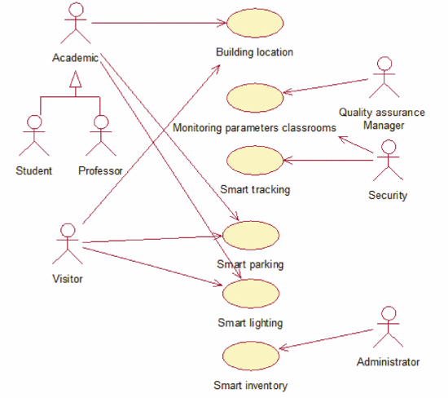

**Figure 1: Use Case Diagram for Smart University**

**3.1.3 Advantages**

***There are many advantages to smart universities, some of which are mentioned as follows:***

* Monitor and track the movement of students and employees across the various corridors, lecture halls spread across the university campus, giving rise to hotspots.
* Regulation of hallway traffic to avoid congestion; This could also be achieved by directing the traffic to the less occupied corridors and pathways dynamically.
* Increase safety and actively prevent accidents and disasters by constantly monitoring features such as noise, smoke, humidity, temperature, and lights in the halls of the organization.
* Consciously collect data from the various sensors and devices, store it in either a cloud-based server or on the university’s local server. This data can then be analysed and used to draw conclusions and develop a dynamic decision-making eco-system.
* Reducing electricity consumption and cut down the cost due to excess energy usage.
* Easily achieving the inventory of technology and equipment.
* Creating an environment conducive to increasing socialization between all members of the university community.
* Using the data accumulated also by others in order to achieve various useful applications.

**3.1.4 Conclusion**

With the number of smart objects connected with IoT increasing regularly, it is normal to increase chances for converting traditional systems into some smart systems. The Smart University model can also be reused in part or as a whole in other domains, both in the educational field (universities, colleges, schools, kindergartens) and in other areas, including private business environment.

**3.2 Smart attendance system based on frequency distribution algorithm with passive RFID tags.**

**3.2.1 Abstract**

Maintaining a reliable attendance system forms a crucial part of any organization’s management. Many conclusions and managerial decisions can be made based on the staff attendance details.

However, the manual method is not only time-consuming but also riddled with high chances of errors. It also entails a constant risk of physical by-passing by some notorious staff members or students. Thus, a fool proof attendance system is an inseparable part of an organization’s management. Radio-Frequency IDentification (RFID) based attendance systems are better than their predecessors in their “strong anti-interference capability and non-intrusiveness”.

“This paper presents a smart attendance system that extracts distinguishable phase characteristics of individuals to enable recognition of various targets. A frequency distribution histogram is extracted as a fingerprint for recognition and the K-means clustering method is utilized for more fine-grained recognition of targets with similar features. Compared with traditional attendance mechanisms, RFID-based attendance systems are based on living biological characteristics, which greatly reduces the possibility of false records. Moreover, the system evaluation shows that our design is robust against differences in the clothing worn and time of day, which further verifies the successful performance of our system.”

**3.2.2 Definitions and Concepts**

**RFID module**

“An RFID tag in its most simplistic form, is comprised of two parts – an antenna for transmitting and receiving signals, and an RFID chip (or integrated circuit, IC) which stores the tag’s ID and other information. RFID tags are affixed to items in order to track them using an RFID reader and antenna.

RFID tags transmit data about an item through radio waves to the antenna/reader combination.

RFID tags typically do not have a battery (unless specified as Active or BAP tags); instead, they receive energy from the radio waves generated by the reader. When the tag receives the transmission from the reader/antenna, the energy runs through the internal antenna to the tag’s chip. The energy activates the chip, which modulates the energy with the desired information, and then transmits a signal back toward the antenna/reader.”

**K-means clustering**

K-means algorithm starts off by assigning random data points as centroids for the clusters. Then the centroids are re-adjusted iteratively.

The algorithm stops the above iterative process when one of the following two conditions are achieved:

• No change in the values of the centroids as compared to the previous iteration, i.e., stability is achieved

• k clusters (i.e., required number of clusters) have been formed

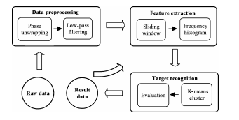

**Figure 2: System Workflow for Attendance System using RFID**

**Doppler Shifts:**

“When a body that is emitting radiation has a non-zero radial velocity relative to an observer, the wavelength of the emission will be shortened or lengthened, depending upon whether the body is moving towards or away from an observer. This change in observed wavelength, or frequency, is known as the Doppler shift.”

**3.2.3 Drawbacks**

Like all systems, this approach too is not flawless. One of the limitations of this system is that the entire system performance and evaluation metrics of the prototype is heavily dependent on just five volunteers, who were invited to participate in this laboratory experiment. We have little to no knowledge of how the results and deductions may be affected if the number of participants is significantly increased. The probability of a greater number of people having similar facial feature increases as the number of people increases. This is handled by making it more fine-grained.

Another major drawback of the system will be that there will be a noticeable latency in the feature extraction, making the implementation static. Real-time implementation must be the goal as it forms a key to building a robust and anti-cheating system.

**3.2.4 Conclusion and Further Work**

“In this paper, we proposed a device-free office attendance system and presented our key motivation, design methodologies, implementation, and evaluation of this system, which can distinguish various targets according to the unique phase signals of individuals in the LOS link, as collected from an RFID reader. To improve system identification accuracy, we used a frequency distribution histogram and a K-means algorithm to extract phase fingerprints. We conducted extensive experiments and the results show that our system performs very well, with an average accuracy of 92%. In future work, we will mainly focus on taking into consideration more phase features to achieve higher recognition accuracy in the identification of more targets.”

# 3.3 Automatic lighting and Control System for Classroom

**3.3.1 Introduction**

India, although a developing country, suffers a serious issue in terms of the supply and demand chain of electricity. This is more pronounced in the smaller towns and villages that are often lacking the basic necessity of modern electricity. They still resort to the age-old techniques of oil lamps, thus putting our country’s growth back by a few hundred years. Even in the major cities, there still exists a problem of electricity shortage, which leads to people getting electricity for only few hours of the day only.

In the 21st century, electricity is a basic human necessity that is required to improve our country in the field of education, professional workforce, modern appliances for day-to-day chores, modern farming equipment, etc. The numerous villages are country are the ones that face the brunt of this unreasonable wastage of electricity. In order for the overall development of our country’s economy, we must pay heed to their energy requirements.

“Although our country has made significant progress towards the augmentation of its power infrastructure, the poor quality of power supply and frequent power cuts and shortages impose a heavy burden on India's fast-growing trade and industry.” The heavy dependence on non-renewable sources for the generation of electricity makes it even more precious and we need to exercise utmost caution in our expenditure of this energy. In light of the current scenario, we observe that educational institutions with a widespread campus such as colleges and universities play a pivotal role in misusing our country’s energy supply. Fan, lights, air conditioners, computers and other electrical appliances are perpetually switched on, irrespective of the presence of a student or faculty.

It is observed that in a few cases, all the fans and lights of a classroom are switched on irrespective of the presence of the students in one remote corner of the room. The amount of energy consumed and essentially wasted in the above scenario is huge. The system is designed to automatically turn off the lights and fans in a room if no person is detected in that grid.

**3.3.2 Methodology**

The entire smart lighting system for classroom are divided into parts which are Hardware sensing unit, Hardware processing unit, Hardware control unit, Network module and Mobile application modules.

The basic idea is to divide the classroom into a number of independent grids using motion sensors that will detect the arrival or departure of a student into a particular grid. The relays and Arduino Uno then work towards automatically turning on the fans and lights that exist in only that area. An additional Bluetooth module is required to implement a mobile application that will facilitate the remote access of all these appliances.

• PIR Sensors – “PIR sensors sense the motion of a person whether they are in the range or outside the range. These sensors are small, inexpensive, low power, easy to use and don't wear out. They are often referred to as PIR, “Passive Infrared”, “Pyroelectric”, or “IR motion” sensors.”

• Arduino UNO – “The parameters such as temperature, humidity, etc have to be analysed, processed and corresponding action according to the stats are been triggered. An Arduino UNO is employed foe this task. “Arduino is a micro-controller and has its own programming language, used to control its functionality which is burnt on the board.” Arduino Uno is a microcontroller board based on the ATMega 328P. It consists of 14 digital I/O pins, 6 analog inputs, 16 MHZ Quartz Crystal, USB connection, Power Jack, ICSP header and reset button.”

• Relays – “Relay is an electrically operated switch which uses an electromagnet towards mechanically operating a switch. Relays are used in appliances where it is deemed necessary to control a circuit by low power signal or when several circuits need to be controlled by a signal.”

• Bluetooth module – “Bluetooth is a wireless technology standard towards data exchange over short distances at an ISM frequency band of 2.4 to 2.485 Mhz. IEEE standardizes Bluetooth as IEEE 802.15.1.”

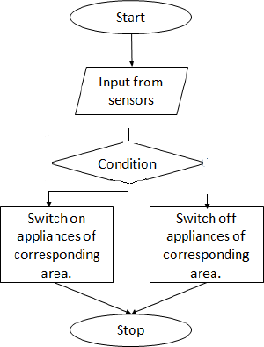

**Figure 3: Flowchart for Automatic Lighting and Control System**

**3.3.3 Implementation**

“The implementation of the entire Automatic lighting control system been carried out using Arduino Uno board with Atmega microcontroller. The Arduino microcontroller is responsible for switching the appliances on and off based on the input received from the PIR motion sensors.

**3.3.4 Conclusion and Further work**

India is a developing country and energy forms one of the major factors that influences our growing economy. Educational institutions, due to the vastness of their campus and the number of students and faculty, are one of the largest sinks that consume energy in our country. Most students and professors have inculcated the habit of leaving the fans, lights and other electrical appliances unattended, leading to a large amount of electricity being consumed unnecessarily. This in turn leads to an increase in the energy related costs of the institution. In order to avoid all of this, many sensor-based solutions have been proposed over the years. But sadly, none of them have found widespread acceptance.

In this paper, they have discussed a system in which the area of the classroom is divided into a number of equal grids by motion sensors placed at various vantage points. They detect the presence of a person in a particular grid, and send a signal to the relay to automatically switch on the corresponding fans and lights.

In future, research can be carried on towards not only switching the appliances on or off but also altering the intensity of lights and speed of fans on the basis of environmental factors such as temperature and humidity. Additionally, a timer feature maybe implemented in addition to the system in order to automatically turn off the appliances, thereby conserving electricity.

**3.4 Smart Attendance Monitoring System (SAMS):**

**3.4.1 Abstract**

In any institution, attendance records hold a lot of prominence in understanding the effectiveness of classes and helps in the management’s constant lookout to improve and enhance the experience of education for both students as well as faculty. Convenience and fault-tolerance are the most important aspects for any smart attendance system. The traditional method of calling out a long list of names is tedious and also time-consuming. This paper talks about a system which is developed by integration of omnipresent components to make a device (usually portable) for managing the students and faculty attendance using the Face Recognition technology.

**3.4.2 Methodology**

***Face Detection***

Face tracking technique has been employed for better accuracy of face-log generation. Firstly, the Viola-James algorithm is used to detect the face, which is then followed by the use of the correlation tracker present in the dlib library for keeping track of the face from one frame to the next frame. “This approach also saves computational power since we don’t have to detect the face after transforming to a new frame in the real-time video sequence. This helps to generate a face-log i.e., a concise representation of the face of the subject in a video sequence.”

***Viola-Jones algorithm***

This algorithm was developed by Paul Viola and Michael Jones in 2001. It is an object-recognition framework that allows the detection of image features in real-time.

“Viola-Jones algorithm was designed for the front-view of the faces, so it is able to detect front profile the best rather than faces looking sideways, upwards or downwards. Before detecting a face, the image is converted into grayscale, since it is easier to work with and there’s lesser data to process. The Viola-Jones algorithm first detects the face on the grayscale image and then finds the location on the coloured image. Viola-Jones outlines a box and searches for a face within the box. It is essentially searching for these Haar-like features, which will be explained later. After inspecting every tile in the current box, the box moves a step to the right. The box size and step size can be adjusted according to need. With smaller steps, a number of boxes detect face-like features and the data of all of those boxes put together, helps the algorithm determine where the face is.”

**3.4.3 Performance of the system**

When a student is exposed to the SAMS for the first time, his/her face is detected and stored int the database. This information is then used to train the model in order to detect the same person in future instances. The system offers self attendance feature in which the GUI (Graphical User Interface) giving a drop-down menu for the recognized face. The drop-down menu consists of a list of most probable students whose face may have a certain degree of similarity. The first name given by the GUI in the drop-down menu has the highest probability for the match.

**3.4.4 Conclusion**

The primary goal of an automated attendance system is to overhaul the traditional and time-consuming system prevalent even today. The implemented system keeps track of attendance by detecting some facial features and then recognizing them. These systems perform convincingly with different facial expressions, poses of the person and lighting in the background.[5] However, one of the major drawbacks of this system is its inability to recognize valid faces from time to time. In the paper, they have made the device portable for easy use even when the class is on, without disruption in the class.

**CHAPTER-4**

**DATA**

* 1. **Overview:**

Total Influx of Data:

The data that would be collected can be briefly segregated into:

• Student Details

• Subject Details

• Teacher Details

• Classroom Appliance Details

* 1. **Dataset:**

Student Details:

Each student would have to register themselves with the system under the oversight of the   
administrator who ensures the information entered is true and valid. They would have to provide their:

• Name

• SRN

• Email

• Number

• Registered Courses

• Place of residence

• Parents/Guardian’s number

• Biometric Fingerprint Scan

Subject Details:

Each subject for the semester would have to be entered along with their respective teacher   
information and the timings as well. This data is mutable as subjects and their timings/teachers are   
subject to change as and when a teacher takes leave/can’t teach on his/her timings. The data to be provided   
would be:

• Subject Name

• Teacher Name

• Number of Credits

• Timings

Teacher Details:

Each teacher will have to register under the system providing their personal details. This is so that  
each teacher can have a separate user account which they can login and view their dashboard which   
would contain provisions to view the number of students attending and the total trend of attendance   
as well as options for her to take leave of class/appear as free for substitution. The data that would   
be collected is:

• Teacher Name

• Teacher ID number

• List of classes being handled by teacher

• Timings of the teacher

Classroom Appliance Details:

Every individual classroom’s electrical devices will be monitored to prevent over usage when the   
classroom is empty as well as when a specific temperature is required. Data pertaining to these   
appliances must be feed in for the system to recognize and integrate the devices to be monitored.   
The data would be:

• Per Classroom Appliances

• Energy Requirement per Appliance

• Temperature Preset per Classroom

Total Outflux of data:

The total data generated by the system can be used for further analysis and is categorized as follows:

• Student Information

• Teacher Information

• Class Room Information

Student Information:

• Attendance reports can be generated on a per student basis based on the classes the student attends

• Said report can also be generated on a bulk basis

• This can be used to highlight trends to see if students actively bunk a specific subject or   
if students collectively bunk at a specific time

Teacher Information:

• Information on how many students attend a teacher’s class and how effective and popular   
it is among the students

• Total influx of students on that particular subject

• Any outliers pertaining to attendance of any student

Classroom Information:

• Trend of appliance usage per classroom

• Effective average temperature of each classroom so this can be automated at a later stage

• Time of the day the classroom is active with people inside

# CHAPTER-5

# SOFTWARE REQUIREMENTS SPECIFICATION

### Product Perspective

We have observed that even if the classrooms have been hugely automated in most of the institutions, there are quite a few loopholes in the previously existing solutions which can be optimized to make the systems full proof. One of those problems is attendance systems. For a long time, attendance has always been taken manually. This has caused multiple discrepancies and has wasted useful class time. We have observed that even if it is automated, there are several flaws. In addition to this, classroom equipment like fans etc. have occasionally been left on thereby wasting considerable energy.

### Product Features

* Automated Attendance System:

A full proof attendance system using a fingerprint scanner attached to a mic system carried by the teacher such that there are minimum loopholes for the students to exploit.

* Electricity Optimization:

Estimating and reducing the average energy footprint of a classroom by using motion sensors to detect if there are students in a certain section of the classroom where the fans/lights are running and using temperature, humidity sensors for optimizing the classroom temperatures thereby aiming at providing a perfect environment to study.

* Cloud-based Dashboard:

Designing a cloud-based dashboard containing a detailed analysis based on the attendance information.

### User Classes and Characteristics

* Students:

The students take the fingerprint scanner from the teacher for every class, mark their attendance and pass it around as their attendance gets marked automatically for that particular class.

* Teachers:

The teachers carry the fingerprint scanner attached to the mic system they usually take to class. Their attendance is marked once the mic is switched on and then they would pass the fingerprint scanner throughout the class for the students to individually mark their attendance.

* System Admin:

The system admin monitors attendance of the students and basically looks after the entire working of the attendance as well as the energy optimization system.

### Operating Environment

* Hardware available in campus: Relays, Wiring, Fans, Tube lights.
* Hardware required for the project: UART Capacitive Fingerprint Sensor, Digital Temperature Controller Thermostat, Tolako 5v Relay Module, PIR Motion Detector Sensor Module HC-SR501, Microcontroller: Raspberry Pico, Transmitter and Receiver.
* Software Components: Wireless Connectivity (Wi-Fi Module), Server: Agile, Django/ IoT Platform like ThingSpeak.

### General Constraints, Assumptions and Dependencies

* Availability of Raspberry Pico:

Raspberry Pico is very new to the market and needs to be tested whether it satisfies all the requirements for the project. As per the documentation, it does seem to satisfy them. As a

backup, we would still have Raspberry Pi ready, but the cost would be more if we use Raspberry Pi instead of Raspberry Pico.

* Server systems in the Institutions:

Our project also highly depends upon how the server system exists at a particular institution. If there is no existing server, it would be very easy to implement. If there exists a server, then we have to check how exactly we will be able to implement our project on it.

* Existing Wiring in Institutions:

It depends which wiring system exists at the institution because our project would work on almost every existing wiring system unless it’s very old.

### Risks

* We assume that the server at the institutions is very easily compatible to our project.
* We also assume that existing wiring and relay system in institutions is not very old such that we cannot even implement our project on those systems.

### Functional Requirements

*Attendance Management System:*

The singular component of smart attendance management system involves analyzing and taking fingerprint scans of student and validating the same over a cloud database.

* Validity Tests Involved:

1. Every student of every classroom will have their individual fingerprints scanned and registered in the class’s database.
2. Upon commencement of classes, a scan of every student who are present is taken and validated in the database, thereby marking them present.

* Error Handling and Recovery:

1. Upon encountering an error, the student may request the teacher after through identification to manually mark the said student as present.
2. The database will employ its own error identification and correction techniques.

* Sequence of Operations

1. Student scans fingerprint
2. Scanner relays finger-print identification data wirelessly to microcontroller.
3. Microcontroller checks online database and verifies attendance.
4. Database logs in time and date as well.

*Classroom Energy Management:*

* Validity Tests Involved:
  + - 1. The power system of the classroom’s compatibility with relays must be ensured for a smooth functioning of power cutoff.
      2. Bidirectional switch connections must be accounted for.
      3. The temperature of the room is checked, and the speed of the fans is adjusted accordingly.
      4. The temperature can be manually overridden.
      5. In the event of the classroom being empty, power must be cut off to all equipment.
* Error Handling and Recovery

1. In the event of an error, circuit breakers are to break the circuit to prevent equipment failure.

* Sequence of Operations

1. Temperature is kept in constant check by the microcontroller.
2. As and when the temperature rises/falls, the fan speed is modulated.
3. When the occupants of the classroom leaves, the power to the lights are cut off.

### External Interface Requirements

* + 1. **User Interfaces**
* Dashboard for the teachers to view attendance.
* Interface for the teachers for manually provide attendance if the sensor fails.
* Controls for the teachers to perform analysis on the intake of students on a per subject basis.
* Controls for the system admin to oversee the registration and authentication of each student.

### Hardware Requirements

* UART Capacitive Fingerprint Sensor
* Digital temperature controller thermostat (Model: Absolute Native Electronics W1209 50~100)
* Tolako 5v Relay Module
* PIR Motion Detector Sensor Module HC-SR501
* Microcontroller: Raspberry Pico/ Raspberry Pi
* Transmitter and Receiver for 1km range.

### Software Requirements

|  |  |  |
| --- | --- | --- |
| Wireless Connectivity | 1 | Wi-Fi Module Specifications:   * Model Number: ESP8266 * Colour: Black * Form Factor: All-in-One * Item Weight: 60.0 grams |
| Server | 1 | * ThingSpeak: Home License * Number of messages: 33 million/year per unit (approximately 90000/day for single unit) * Message update interval limit: 1 second * Number of channels: 10 per unit |

**Table 1: Software Requirements**

* + 1. **Communication Interfaces**
* Wi-Fi: Connectivity of each of the microcontrollers on every floor will be ensured through Wi-Fi.
* Bluetooth: Connectivity of the fingerprint scanner to the microcontroller will be ensured through Bluetooth.

### Non-Functional Requirements

* + 1. **Performance Requirement:**

Our product is designed to be extremely versatile, and it doesn’t have any specific conditions to work under and no external factors are going to affect the performance of the product. The fingerprint scanner is also extremely reliable as it will still be able to take a reading regardless of external factors. As for the smart classroom system, the sensors are easily available and are very effective for the use that we are putting them to and are not that easily affected by external factors.

### Safety Requirements:

Our project uses a 5V relay which allows a relatively low voltage to easily control higher power circuits. A relay accomplishes this by using the 5V outputted from a microprocessor pin to energize the electromagnet which in turn closes an internal, physical switch to turn on or off a higher power circuit.

### Security Requirements:

Security is not an issue with our product as the device will always be in the possession of the teacher and all the microcontrollers for the electricity saving model will be in the possession of the floor admin. The data collected will be stored safely on a server which is only accessible by the system admin.

# CHAPTER-6

**SYSTEM DESIGN**

### Design Considerations

* + 1. **Design Goals**

### Attendance:

1. Attendance can be taken electronically by means of a biometric optical fingerprint scanner.
2. Security and integrity can be ensured by making the biometric module portable and modular - a small phone sized module carried by the teachers.
3. The teacher can pass around/have each of the students scan their prints and register their attendance with no manual intervention.

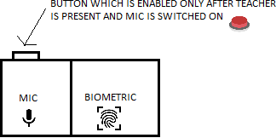

**Figure 4: Block Diagram for Smart Attendance System**

### Electricity Optimization:

1. Spatial sensors placed at the edges of classrooms will notify the system of movement and activity in the room.
2. Edge computed algorithms ensure that the lights and fans are turned on only at specific portions of the room incase of a large classroom/hallway.
3. In case of manual fans, temperature monitors are used to add a level of cost-effective automation.

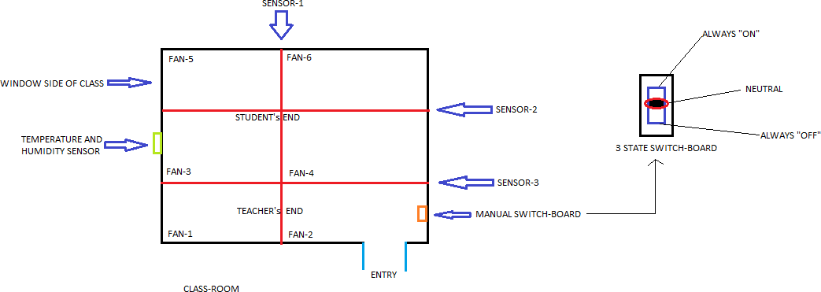

**Figure 5: Block Diagram for Electricity Optimization System**

* We are trying to build a fool-proof system in this project considering the ways students can bypass these systems.
* Real-time implementation of the project that is independent of wiring system of the institutions.

### Architecture Choices

Multiple alternate ways to take attendance were considered however, none of them proved to be as reliable and as viable as our solution as most of them proved to be too unwieldy or posed a security concern or straight up could be tampered with:

* *Attendance Logging via Face Detection:*

Attendance to be logged in via a camera that would use algorithms that would detect faces.

* Pros:

1. Simple and easy for students.
2. Seamless attendance by just showing your face in the camera as you walk in.
3. Zero Time wasted as attendance is taken as students walk in.

* Cons:
  + 1. Very unwieldy, may not work accurately.
    2. Lot of variables deciding its effectiveness such as lighting etc.
    3. Twins and lookalikes may pose an issue.
    4. Actual logging may take time as algorithms take time to recognize faces.
* *Attendance Logging via Single fingerprint scanner:*

Attendance to be logged in via a single fingerprint scanner placed at the entrance of the classroom.

* Pros:
  + 1. Makes the teacher’s life easier as students can manage taking their attendance themselves.
    2. Less expensive as fingerprint scanner to be considered doesn’t need to be portable or high tech.
    3. No inaccuracies as fingerprints are an extremely reliable means of identification.
* Cons:
  + 1. Easier to tamper: Students can just log in to the attendance and walk out of the classroom, hence registering a false attendance.
    2. No overseeing by the teacher as she has no control over classroom- based sensors.

Eventually, our system was devised which provided the maximum balance between functionality and cons:

* *Attendance taken via individual scanners held by teachers:*
* Pros:
  + 1. Teachers have full control over when they can take attendance as the device is constantly with them.
    2. Students cannot fake attendance as the teacher decides when the attendance can be taken once everyone has been settled in the class and the door has been closed.
    3. Students can’t log in attendance and walk out of the class as the device would be passed along in the classroom.
    4. Teachers can give explicit attendance under their own discretion such as when a student walks in late etc.
* Cons:
  + 1. Expensive: Involves the purchase of high-end scanners that can be condensed into portable modules for easy handling.
    2. Involves some time wastage as students need to log in attendance one by one once everyone has settled in.
    3. The device may be prone to damage if it has been extensively being passed on.

### Constraints, Assumptions and Dependencies

* Availability of Raspberry Pico:

Raspberry Pico is very new to the market and needs to be tested whether it satisfies all the requirements for the project. As per the documentation, it does seem to satisfy them. As a backup, we would still have Raspberry Pi ready, but the cost would be more if we use Raspberry Pi instead of Raspberry Pico.

* Server systems in the Institutions:

Our project also highly depends upon how the server system exists at a particular institution. If there is no existing server, it would be very easy to implement. If there exists a server, then we have to check how exactly we will be able to implement our project on it.

* Existing Wiring in Institutions:

It depends which wiring system exists at the institution because our project would work on almost every existing wiring system unless it’s very old.

### High Level System Design

* *Logical User Groups:*
* Teachers:

The teacher is given dashboard permissions to view and manage the attendance and given regular updates as to when the students come to class. The teacher is also given notifications in case of any outliers and can also edit attendance as and when necessary.

* Students:

The students have permissions to only log in the attendance via fingerprint under the teacher’s discretion when the teacher so allows it. The student has no further permissions and if he/she wishes to edit her attendance due to any issue/manual logging, they can only approach the teacher and the teacher can do so under her discretion. The student can also control the temperature of the room and its lighting.

* + - Administrator:

The administrator oversees all the attendance and the database functions. Only the administrator has full access to the database and its core. Every single operation undertaken by the teacher and the student is logged into an audit log. The admin has access to this log and in the event of any emergency/malpractice, the administrator has a clear view of what is happening at all times. He/she also has access to the database and its connections and can undertake any database operations if necessary.

* *Data Components:*
* Raw Fingerprint Data:

This is the raw fingerprint values which registers every time a student scans his/her fingerprint.

* Power Consumption Values:

These values are logged for database analysis purposes. They are the total power consumption values on an hourly basis per classroom.

* Current Room temperature:

This stat is the current room temperature which will be monitored. It is according to this stat that the appliances such as fans will be modulated.

* Database connectors:

All data and actions taken by the device will be relayed onto the database via database connector which will be running on the microcontroller. Every action including the actions of all users in the user groups will be logged via an audit log.

### Design Description

* + 1. **Master Class Diagram (Figure 6)**

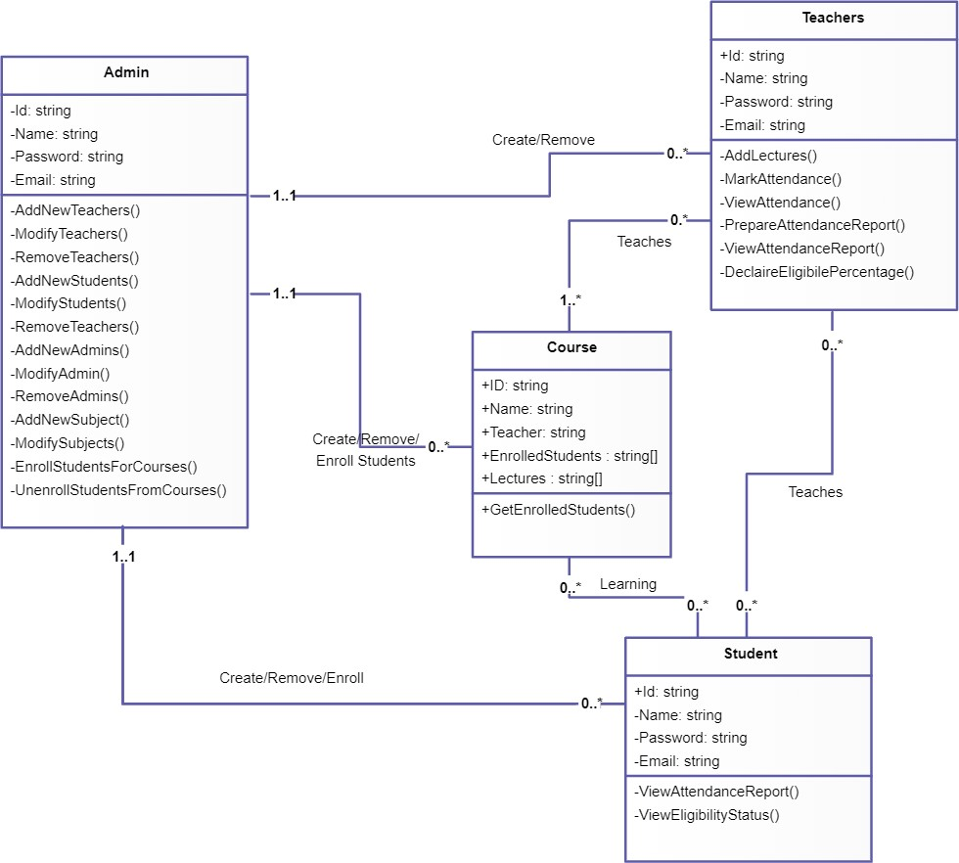

### Reusability Considerations

* The assortment IoT sensors installed in the classrooms are durable and need not be replaced often.
* The server installation too is a one-time process. However, the ThingSpeak and Firebase backends need to be paid for on a yearly basis depending on the usage.
* The ML models used for attendance summarization and fan speed detection are reused and some extra layers(mechanism) have been added on top of that. These models are constantly learning from manual user intervention.

### State Diagrams

* Attendance: (Figure 7)

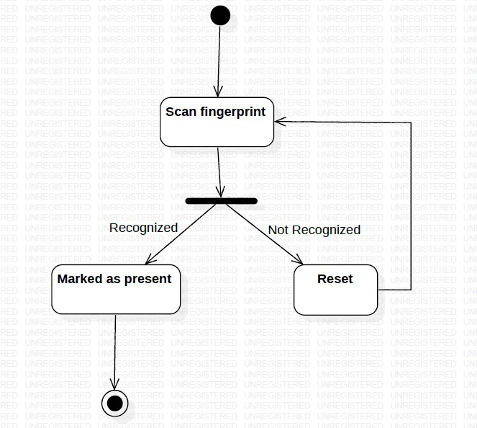

* Electricity Optimization: (Figure 8)

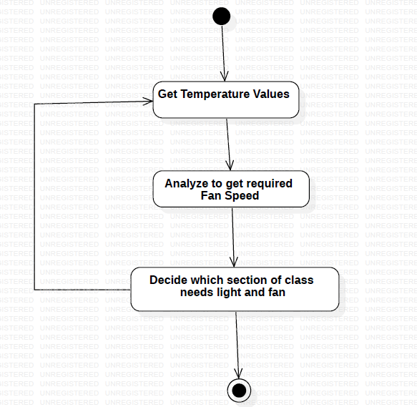

### User Interface Diagrams (Figure 9)

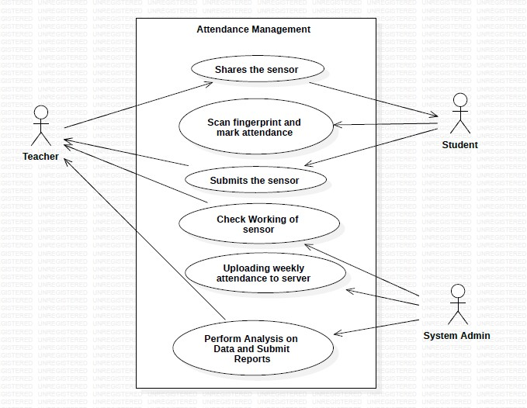

* 1. **External Interfaces**

### User Interfaces

* Dashboard for the teachers to view attendance.
* Interface for the teachers for manually provide attendance if the sensor fails.
* Controls for the teachers to perform analysis on the intake of students on a per subject basis.
* Controls for the system admin to oversee the registration and authentication of each student.

### Hardware Requirements

* UART Capacitive Fingerprint Sensor
* Digital temperature controller Thermostat (Model: Absolute Native Electronics W1209 50~100)
* Tolako 5v Relay Module
* PIR Motion Detector Sensor Module HC-SR501
* Microcontroller: Raspberry Pico/ Raspberry Pi
* Transmitter and Receiver for 1km range.

### Software Requirements (Same as Table 1)

|  |  |  |
| --- | --- | --- |
| Wireless Connectivity | 1 | Wi-Fi Module Specifications:   * Model Number: ESP8266 * Color: Black * Form Factor: All-in-One * Item Weight: 60.0 grams |
| Server | 1 | * ThingSpeak: Home License * Number of messages: 33 million/year for a single unit. (approx. 90,000/day per unit) * Message update interval limit: 1 second * Number of channels: 10 per unit |

**Communication Interfaces**

* Wi-Fi: Connectivity of each of the microcontrollers on every floor will be ensured through Wi-Fi.
* Bluetooth: Connectivity of the fingerprint scammer to the microcontroller will be ensured through Bluetooth.

### Packaging and Deployment Diagram

Packaging Diagram: (Figure 10)

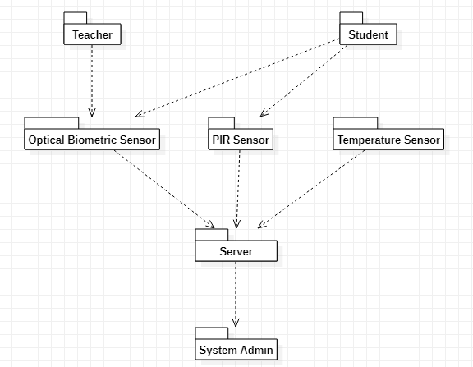

Deployment Diagram:

* Attendance System (Figure 11)

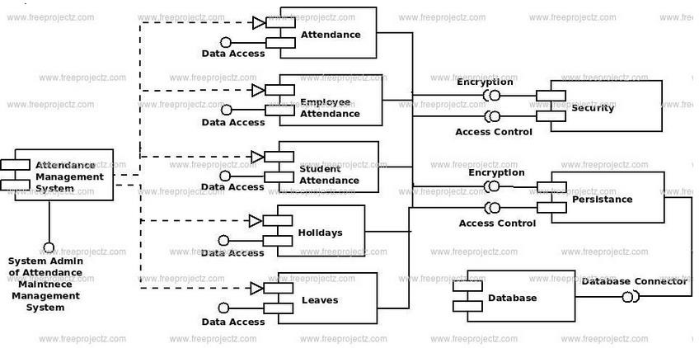

* 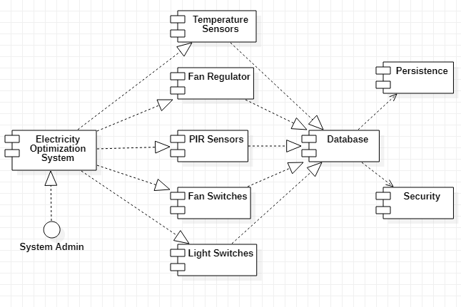Electricity Optimization (Figure 12)

### Help

A User Manual Page will be provided along with the guidelines and related diagrams for easy installation of our system. It would also contain the maintenance procedure on how to go about using the application and preventing the end user from stalling at any point.

As the admin will be the only point of interaction, a proper documented API documentation will be provided to the administrator. This will be generated using the POSTMAN software.

### Design Details

* + 1. **Novelty**
* Fool proof solution is important keeping in mind the innovative ways students find to bypass attendance systems.
* Real-time implementation that is independent of the wiring system.

### Innovativeness

* Dashboard for the teachers to view attendance.
* Interface for the teachers for manually provide attendance if the sensor fails.

### Interoperability

* Controls for the teachers to perform analysis on the intake of students on a per subject basis.
* Controls for the system admin to oversee the registration and authentication of each student.

### Performance

* + - * Our product is designed to be extremely versatile, and it doesn’t have any specific conditions to work under and no external factors are going to affect the performance of the product.
      * The fingerprint scanner is also extremely reliable as it will still be able to take a reading regardless of external factors.
      * As for the smart classroom system, the sensors are easily available and are very effective for the use that we are putting them to and are not that easily affected by external factors.

### Security

* Security is not an issue with our product as the device will always be in the possession of the teacher and all the microcontrollers for the electricity saving model will be in the possession of the floor admin.
* The data collected will be stored safely on a server which is only accessible by the system admin.

### Reliability

* The fingerprint scanner is very reliable and will be able to take the readings irrespective of the external factors and conditions.
* The temperature sensors too are not that easily affected to external factors.

### Maintainability

* The fingerprint scanners would be checked regularly.
* The students also can report to the teachers if there is some problem with the fingerprint scanner.
* The temperature sensors can be replaced occasionally and the best way to know that a sensor is not running is when it does not send any data across or it sends irregular data.

### Portability

* The fingerprint scanner is attached with the mic and will be carried by the respective teachers to the classes they visit.

### Reusability

* After implementation, we can extend this project to various other institutions and organizations.

### Application compatibility

* This system is compatible with any organization and institution since it is independent of the wiring system.

# CHAPTER-7

**CONCLUSION OF CAPSTONE PROJECT PHASE - 1**

As we come to the completion of phase 1 of our project, we would just like to go over what we have completed so far.

* Identified a valid problem statement.
* Read and went through multiple research papers for reference and ideas to help us formulate a plan to tackle the problem statement.
* Found out Functional and Non-Functional requirements.
* Created a cost estimation document containing all the hardware that will be used also segregating the recurring costs and the onetime costs.
* Compared our design to the old one showing key differences as to why our design is better.
* Created a documented high level design document containing the following:
  + - 1. Master Class Diagram
      2. Architecture Choices
      3. State Diagrams
      4. User-Interface Diagrams
      5. External-Interfaces
      6. Packaging and Deployment Diagrams for both our Solutions.
      7. Design Details

**CHAPTER-8**

**PLAN FOR CAPSTONE PROJECT PHASE - 2**

Going into the next phase of our project, the first thing we have to do is to assemble the sensors together for our product and come up with a “prototype” of our product which will then lead to the first wave of testing and we will be collecting feedback and then making desire changes and testing till we get the outcome we desire.

After that we will begin the integration of the product with the cloud server to store all the data that we will be collecting from our sensors, making the AI models, continue with the final wave of testing, provide the demo.

# REFERENCES

1. Y. Mehmood, F. Ahmad, I. Yaqoob, A. Adnane, M. Imran and S. Guizani, "Internet-of-Things-Based Smart Cities: Recent Advances and Challenges," in IEEE Communications Magazine, vol. 55, no. 9, pp. 16-24, Sept. 2017, doi: 10.1109/MCOM.2017.1600514.

<https://ieeexplore.ieee.org/abstract/document/8030479>

1. <https://www.vxchnge.com/blog/iot-statistics>
2. AItalk: a tutorial to implement AI as IoT devices

<https://ietresearch.onlinelibrary.wiley.com/doi/pdfdirect/10.1049/iet-net.2018.5182>

1. M. Caţă, "Smart university, a new concept in the Internet of Things," 2015 14th RoEduNet International Conference - Networking in Education and Research (RoEduNet NER), 2015, pp. 195-197, doi: 10.1109/RoEduNet.2015.7311993. <https://ieeexplore.ieee.org/abstract/document/7311993>
2. Q. Miao, F. Xiao, H. Huang, L. Sun and R. Wang, "Smart attendance system based on frequency distribution algorithm with passive RFID tags," in Tsinghua Science and Technology, vol. 25, no. 2, pp. 217-226, April 2020, doi: 10.26599/TST.2018.9010141.

<https://ieeexplore.ieee.org/stamp/stamp.jsp?tp=&arnumber=8821515>

1. J. Yu, W. Gong, J. Liu, L. Chen, K. Wang and R. Zhang, "Missing Tag Identification in COTS RFID Systems: Bridging the Gap between Theory and Practice," in IEEE Transactions on Mobile Computing, vol. 19, no. 1, pp. 130-141, 1 Jan. 2020, doi: 10.1109/TMC.2018.2889068. <https://www2.cs.sfu.ca/~jcliu/Papers/MissingTagIdentification.pdf>
2. Suresh S., H. N. S. Anusha, T. Rajath, P. Soundarya and S. V. P. Vudatha, "Automatic lighting and Control System For Classroom," 2016 International Conference on ICT in Business Industry & Government (ICTBIG), 2016, pp. 1-6, doi: 10.1109/ICTBIG.2016.7892666. <https://ieeexplore.ieee.org/abstract/document/7892666>
3. S. Bhattacharya, G. S. Nainala, P. Das and A. Routray, "Smart Attendance Monitoring System (SAMS): A Face Recognition Based Attendance System for Classroom Environment," 2018 IEEE 18th International Conference on Advanced Learning Technologies (ICALT), 2018, pp. 358-360, doi: 10.1109/ICALT.2018.00090. <https://ieeexplore.ieee.org/abstract/document/8433537>
4. IOT AND AI IN HEALTHCARE: A SYSTEMATIC LITERATURE REVIEW <https://iacis.org/iis/2018/3_iis_2018_33-41.pdf>
5. S. M. Felix, S. Kumar and A. Veeramuthu, "A Smart Personal AI Assistant for Visually Impaired People," 2018 2nd International Conference on Trends in Electronics and Informatics (ICOEI), 2018, pp. 1245-1250, doi: 10.1109/ICOEI.2018.8553750. <https://ieeexplore.ieee.org/abstract/document/8553750>
6. V. Chamola, V. Hassija, V. Gupta and M. Guizani, "A Comprehensive Review of the COVID-19 Pandemic and the Role of IoT, Drones, AI, Blockchain, and 5G in Managing its Impact," in IEEE Access, vol. 8, pp. 90225-90265, 2020, doi: 10.1109/ACCESS.2020.2992341. <https://ieeexplore.ieee.org/abstract/document/9086010>
7. A review on intelligent process for smart home applications based on IoT: coherent taxonomy, motivation, open challenges, and recommendations.

<https://link.springer.com/article/10.1007/s10462-018-9648-9>

1. W. Chen, Y. Lin, F. Ng, C. Liu and Y. Lin, "RiceTalk: Rice Blast Detection Using Internet of Things and Artificial Intelligence Technologies," in IEEE Internet of Things Journal, vol. 7, no. 2, pp. 1001-1010, Feb. 2020, doi: 10.1109/JIOT.2019.2947624. <https://ieeexplore.ieee.org/document/8871173>
2. D. He and S. Zeadally, "An Analysis of RFID Authentication Schemes for Internet of Things in Healthcare Environment Using Elliptic Curve Cryptography," in IEEE Internet of Things Journal, vol. 2, no. 1, pp. 72-83, Feb. 2015, doi: 10.1109/JIOT.2014.2360121. <https://ieeexplore.ieee.org/document/6907930>
3. R. Sarmah, M. Bhuyan and M. H. Bhuyan, "SURE-H: A Secure IoT Enabled Smart Home System," 2019 IEEE 5th World Forum on Internet of Things (WF-IoT), 2019, pp. 59-63, doi: 10.1109/WF-IoT.2019.8767229. <https://ieeexplore.ieee.org/document/8767229>

# APPENDIX A: DEFINITIONS, ACRONYMS AND ABBREVIATIONS

* ThingSpeak: It is an open-source IoT application and API which is used for storing and retrieving data using different protocols like HTTP and MQTT using the Internet or via Local Area Network (LAN).
* Capacitive Fingerprint Scanner: A device used to record fingerprint of the user by using the capacitance to gauge the depth of the finger.
* Relay: It is basically a switch which is electrically operated. It has a set of input terminals for a different control signals (single or multiple), and a set of operating contact terminals as well.
* Thermostat: It is a device which uses the temperature of the environment around it and performs few actions such that the overall temperature is maintained near a desired value.
* Microcontroller: A microcontroller is basically a mini-computer on a single semiconductor(metal-oxide) integrated circuit chip.

# APPENDIX B: USER MANUAL

# 1. Attendance Systems:

# Attendance can be taken electronically by means of a biometric optical fingerprint scanner.

# Security and integrity can be ensured by making the biometric module portable and modular - a small phone sized module carried by the teachers.

# The teacher can pass around/have each of the students scan their prints and register their attendance with no manual intervention.

# 2. Electricity Optimization:

# Spatial sensors placed at the edges of classrooms will notify the system of movement and activity in the room.

# Edge computed algorithms ensure that the lights and fans are turned on only at specific portions of the room incase of a large classroom/hallway.

# Incase of manual fans, temperature monitors are used to add a level of cost-effective automation.